**What is Faraday’s Law**

**Faraday’s law of electromagnetic induction** (referred to as **Faraday’s law**) is a basic law of [electromagnetism](https://www.electrical4u.com/electromagnetic-theory/) predicting how a [magnetic field](https://www.electrical4u.com/magnetic-field/) will interact with an [electric circuit](https://www.electrical4u.com/electric-circuit-or-electrical-network/) to produce an electromotive force (EMF). This phenomenon is known as electromagnetic induction.

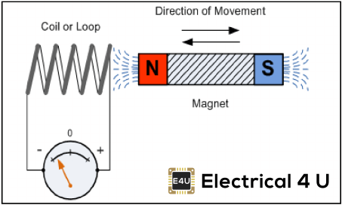

Faraday’s law states that a current will be induced in a conductor which is exposed to a changing magnetic field.

[Lenz’s law of electromagnetic induction](https://www.electrical4u.com/lenz-law-of-electromagnetic-induction/) states that the direction of this induced current will be such that the magnetic field created by the induced current **opposes** the initial changing magnetic field which produced it. The direction of this current flow can be determined using [Fleming’s right-hand rule](https://www.electrical4u.com/fleming-left-hand-rule-and-fleming-right-hand-rule/).

Faraday’s law of induction explains the working principle of [transformers](https://www.electrical4u.com/what-is-transformer-definition-working-principle-of-transformer/), [motors](https://www.electrical4u.com/electrical-motor-types-classification-and-history-of-motor/), [generators](https://www.electrical4u.com/electric-generator/), and [inductors](https://www.electrical4u.com/what-is-inductor-and-inductance-theory-of-inductor/).

### Statically induced E.m.f:-

Statically induced e.m.f is two types which are –  
i) Mutually-induced e.m.f.  
ii) Self-induced e.m.f.

### Mutually induced e.m.f:-



Mutually induced e.m.f occurs in between two coils. Let, A & B are two coils which are placed close to each other. If coil A is joined to a battery a switch and a variable resistance R and coil B is connected to a sensitive voltmeter G. When the switch S is closed , a current will flow through the coil A and produce a magnetic field in which partly links with the coil B. As current through A is changed, the flux linked with B is also changed. According to Faraday’s law, induced e.m.f is produced in the coil B and This e.m.f know as mutually induce e.m.f.

In the above example, there is no movement of any conductor, the flux variation being brought about by variation in current strength Only. Such an e.m.f induced in one coil by influence of the other coil is called mutually induced e.m.f.

### Self-induced e.m.f:



Self-induced e.m.f is the e.m.f which is produced in the coil due to the change of its own flux linked with it. If the current of the coil is changed, then the flux linked with its own turns will also change which will produce an e.m.f that is called self-induced e.m.f.

### Dynamically induced e.m.f:-

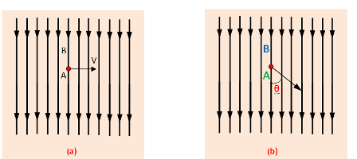

We can see from the figure that a conductor A is lied within a uniform magnetic field whose flux density is a uniform magnetic field . and the flux density is B wb 3. In this fig. the movement of the conductor is shown by arrow line. When the conductor A cuts across at right angles to the flux.

Let, ‘l’= Length of the conductor lying within the field. And it moves a distance dx in time dt, So, the area swept by the conductor is =ldx. Hence, flux cut by the conductor = l.dx X B, Change in Flux = B.l.dx weber, Time= dt second

According to Faraday’s laws. The e.m.f induced in the conductor . And this induced e.m.f is known as dynamically induced e.m.f.

http://www.electricalunits.com/Image/Basic-electrical/emf2.png

If the conductor (A) moves at an angle θ with the direction of flux which is shown in (b).

http://www.electricalunits.com/Image/Basic-electrical/emf1.png

An example, the generator works on the production of dynamically induced e.m.f in the conductors.